**User Interface Design**

**Version 1.3**

**Project Management App**

**Team A**

**CSC-354**

**Fall 2015**

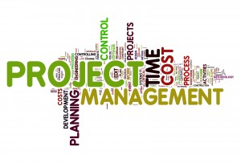

11/12/2015

Author:

Submitted To: Dr. Joo Tan

**TABLE OF CONTENTS**

Revision History…………………………………………………………………………………..ii

1.0 Introduction……..….....…………………………….…...…………………………….……....1

1.1 What is High Fidelity?...................................................................................................1

1.2 Purpose..……………………………….………………………………………………1

2.0 Screen Flow Diagram…………………………………………………………………………2

3.0 Wireframes………………………………………………………………………………….…3

3.1 Initial Icon………...………...………………………………………………………...4

3.2 Splash Screen……………....…………………………………………………………5

3.3 Create Account Screen...……………….……………………………………………..6

3.4 Login Screen………………………………………………………...……………......7

3.5 Tutorial Screen…….……………………………………………...…………………..8

3.6 Main Menu Screen...………………………………………………………………….9

3.7 Create Project Screen..………………………………………………………………10

3.8 Project Screen...…………………………………………………………………….11

3.9 Profile Screen……………………………………………………………………….12

3.10 Member’s View Screen….…………….……………………………………………13

3.11 Leader’s View Screen……..…………………...…………………………………...14

3.12 Progress Screen……...……………………………………………………………...15

3.13 Calendar Screen…...………………………………………………………………..16

3.14 Task List Screen..…………….…………………………………………………….17

3.15 Message Screen………………...…………………………………………………...18

3.16 Member List Screen………………….……………………………………………..19

**REVISION HISTORY**

|  |  |  |  |
| --- | --- | --- | --- |
| Version | Author | Description | Date |
| 1.0 | Hector Richiez | I created the frame that will be used for UID | 11/08/2015 |
| 1.1 | Tyler Mariano | I created the screen flow diagram and added all fifteen screen wireframe diagrams to the document. | 11/11/2015 |
| 1.2 | Hector Richiez | Added the paragraphs for the different screens explanation. | 11/12/2015 |
| 1.3 | Tyler Mariano | I redid the text styling and format of the document as well as changing headers and table of contents sections. | 11/12/2015 |

**1.0 INTRODUCTION**

This document presents the graphical interface of the Project Management App by using first, a screen flow diagram that shows the user the flow of interaction between the user and the App. Second it presents different screens structured in a high-fidelity prototypes to give the user a look and feel of the GUI interface of the project Management App.

**1.1 What is High Fidelity?**

High-fidelity prototypes offers a detailed presentation of the graphical interface of an application. It usually resembles and behaves as the final product. High fidelity prototypes was chosen as the tool to present to the user the Project Management App’s GUI interface.

**1.2 Purpose**

The purpose of this document is to give the end user an idea of the flow of information when interacting with the Project Management App and an idea of the look and feel of the final product upon delivery. It also serves as a point for users to start familiarizing with the 16 different screens that the final product will have to give users a comfortable experience through it’s simple but robust GUI interface

**2.0 SCREEN FLOW DIAGRAM**

The screen flow diagram shows in a hierarchical way the flow of interaction that the user and the system could maintain as the user is navigating through the application’s GUI to accomplish a desired task.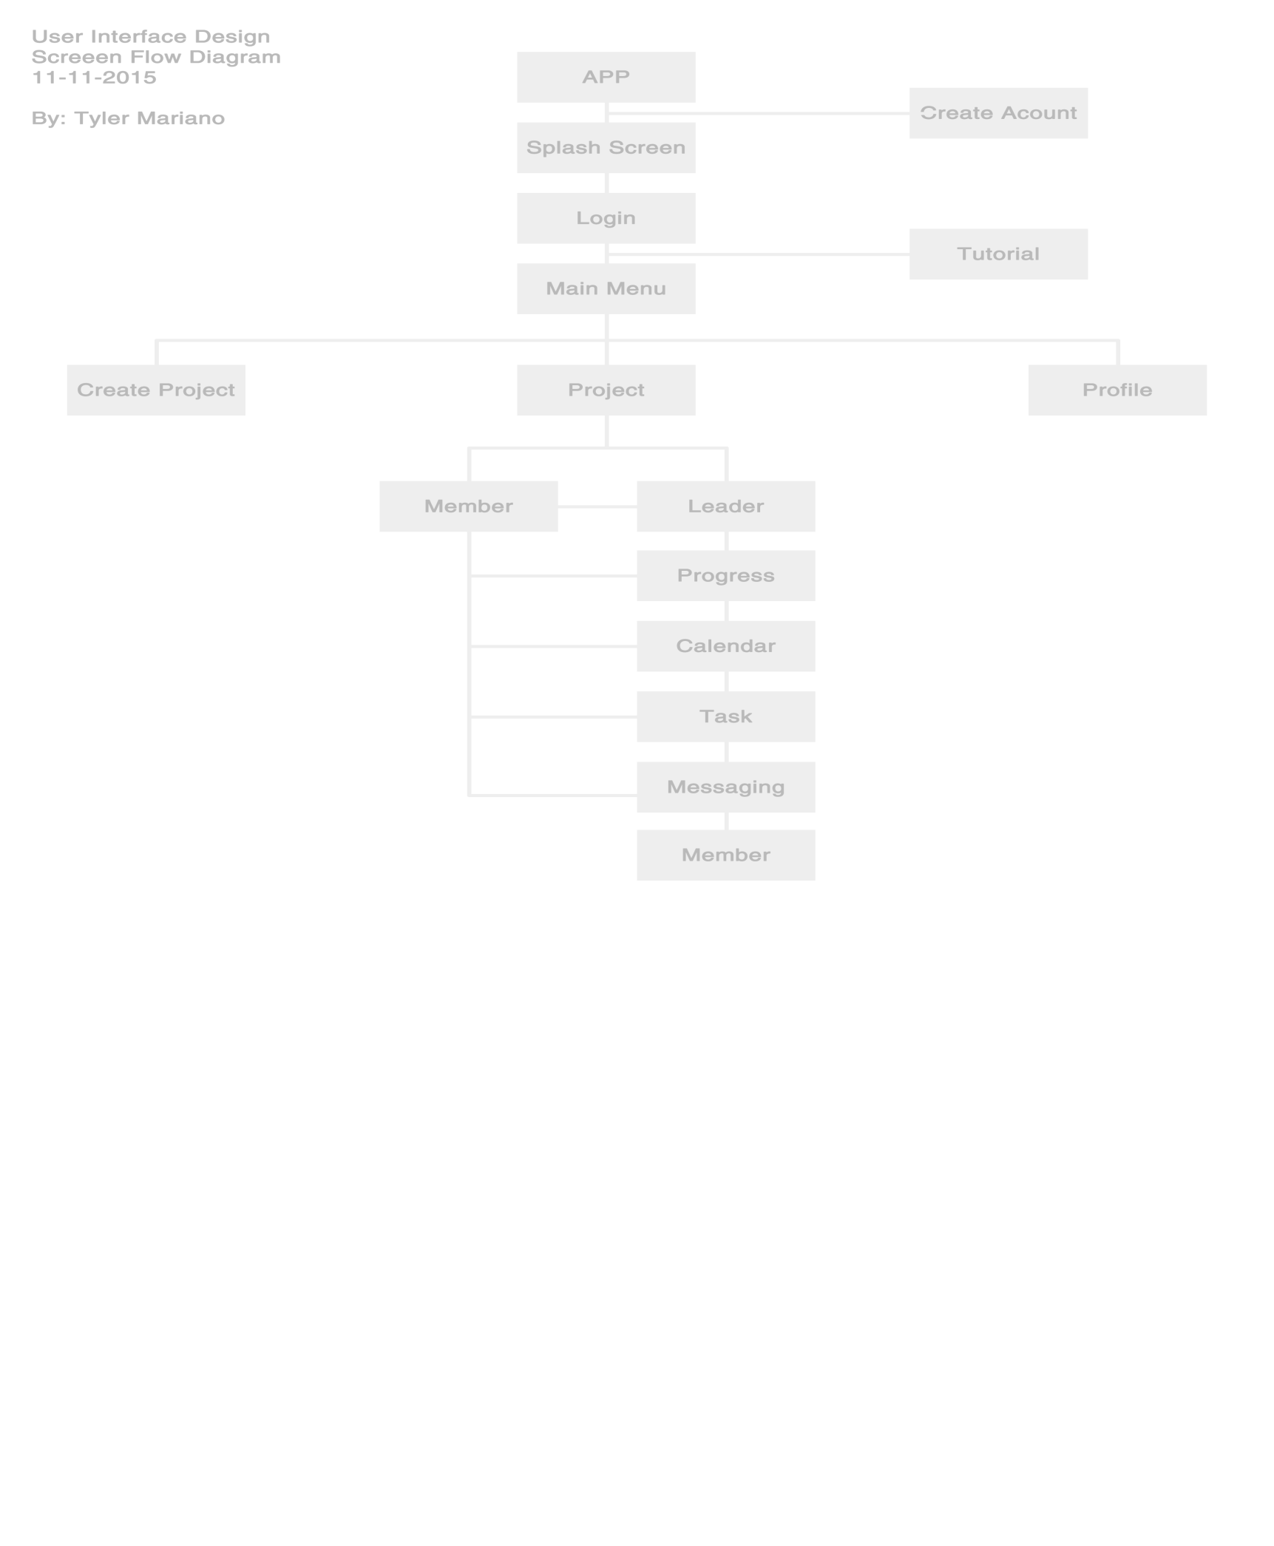

**3.0 WIREFRAMES**

Hi Hector, please add a paragraph here.

**3.1 Initial Icon**

The initial pictogram of the App represents the icon the user will see in their devices. Clicking the Icon will start running the application.



**3.2 Splash Screen**

The splash screen will present the user with the logo of the Project Management App, as well as the date created and the current version.

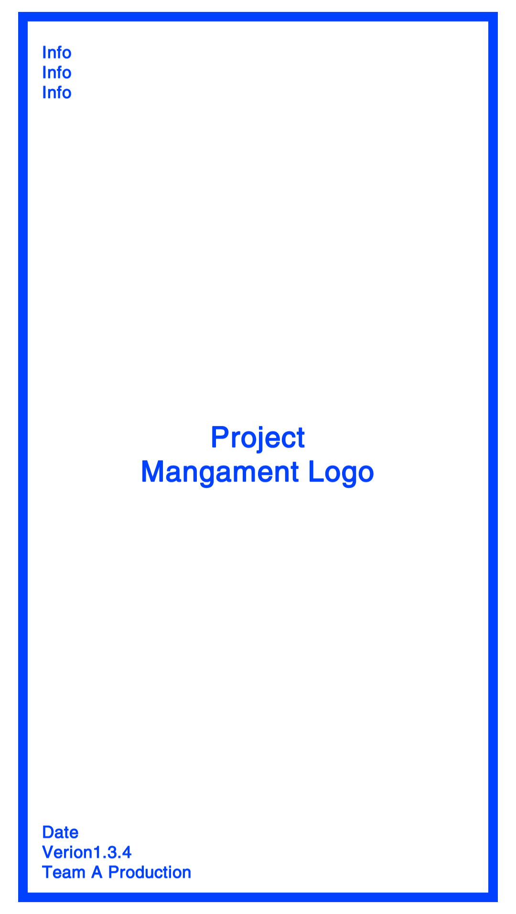

**3.3 Create Account Screen**

The create account screen is the one that starts the interaction between the user and the App. it will ask for the user to create an account so he or she can start using the Application. To create an account the user will have to provide the system with a user name and a password. There are 3 textboxes that will need to be filled out before an account could successfully be created.

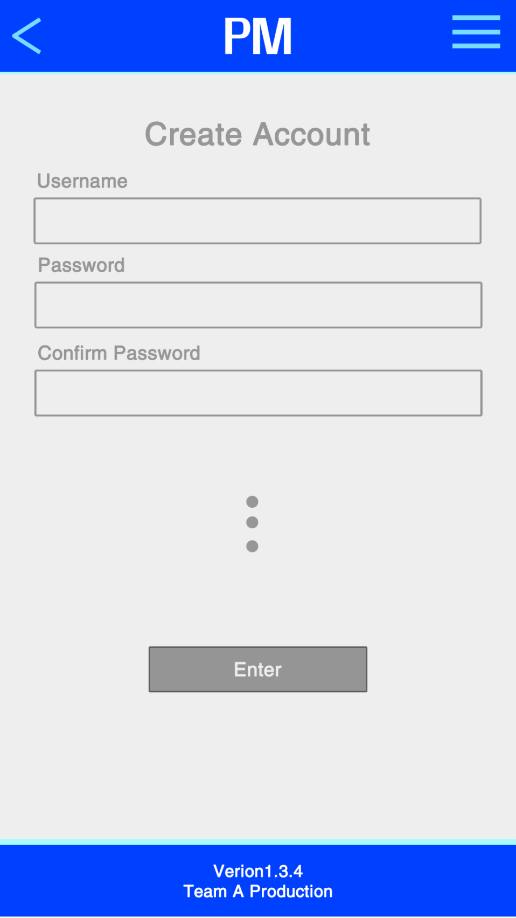

**3.4 Login Screen**

The login screen asks the user for a user password and a username. When both textboxes are filled with the required information, the login button will be available for the user to click and login to the APP.

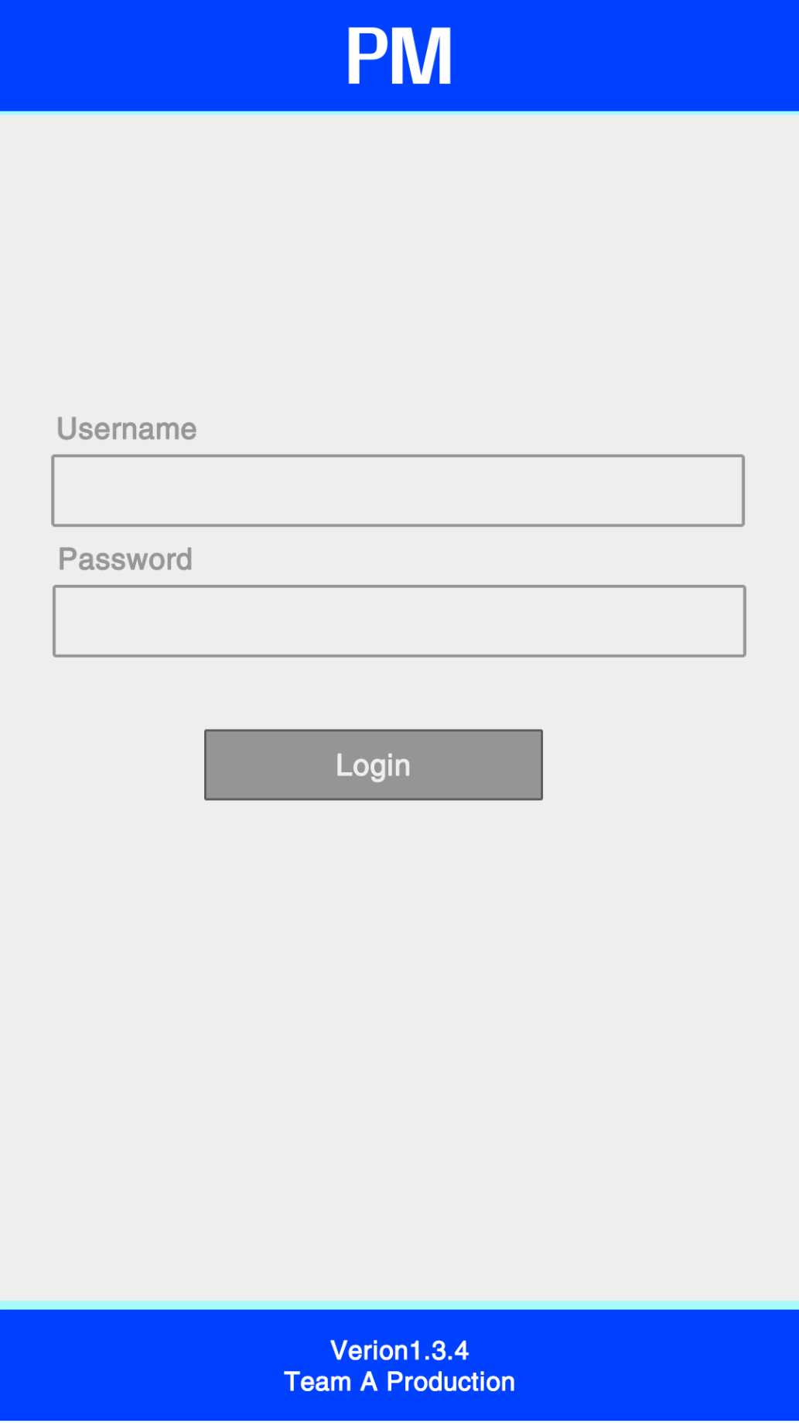

**3.5 Tutorial Screen**

The tutorial screen serves as a learning resource that the application users have to their advantage to learn how to navigate through the App, learn shortcuts, use efficiently the services provided by the application and how to start a project, add members, assign task, upload completed task and view tasks and project progress.

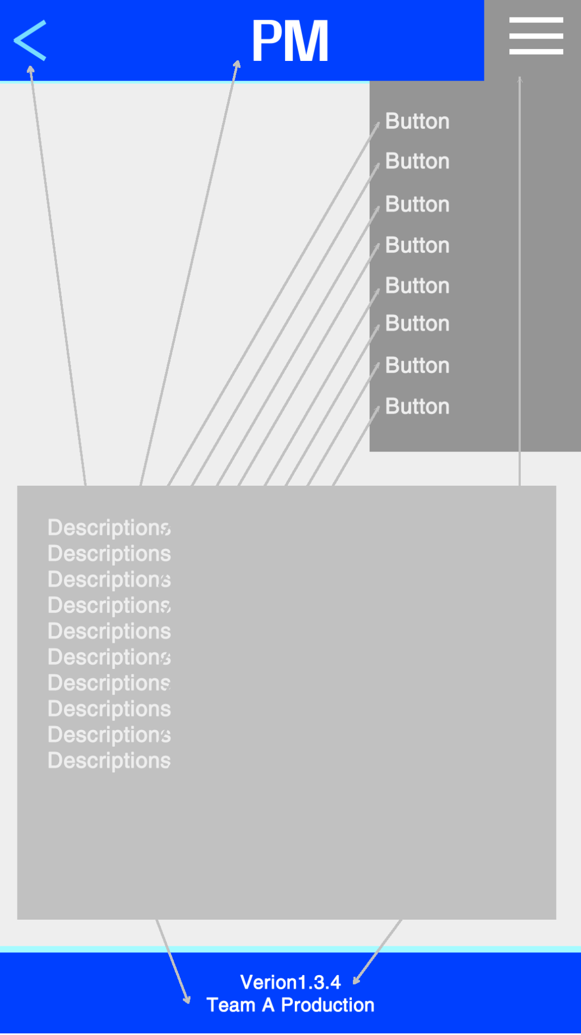

**3.6 Main Menu Screen**

The Main menu screen is the screen the users will see when they create an account and have logged in for the first time. In this screen the user will be able to create a project or multiple projects.

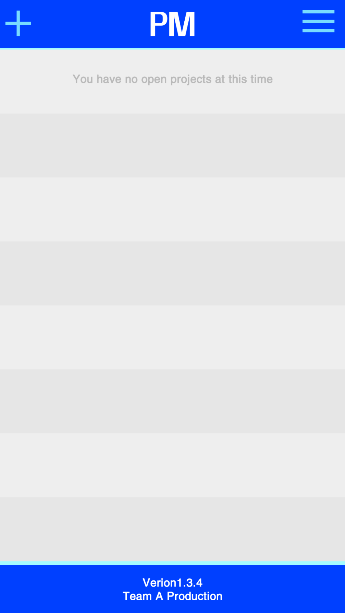

**3.7 Create Project Screen**

The create project screen is where the user can enter the requested information to create a project. To create a project the leader of the project will have to provide the system with a project name, description, estimated cost, and a the names of the potential members of the project.

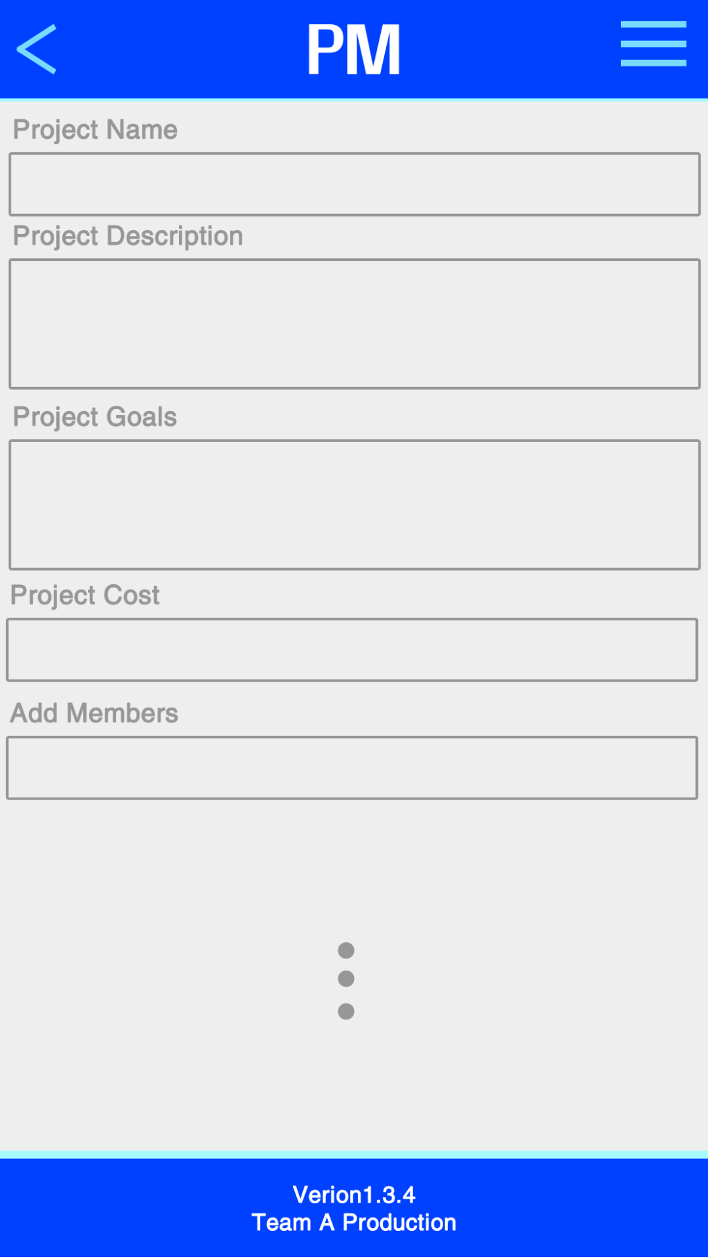

**3.8 Project Screen**

The project screen is an informative screen that provides a description of the project, its goal, cost and members that are part of the project.

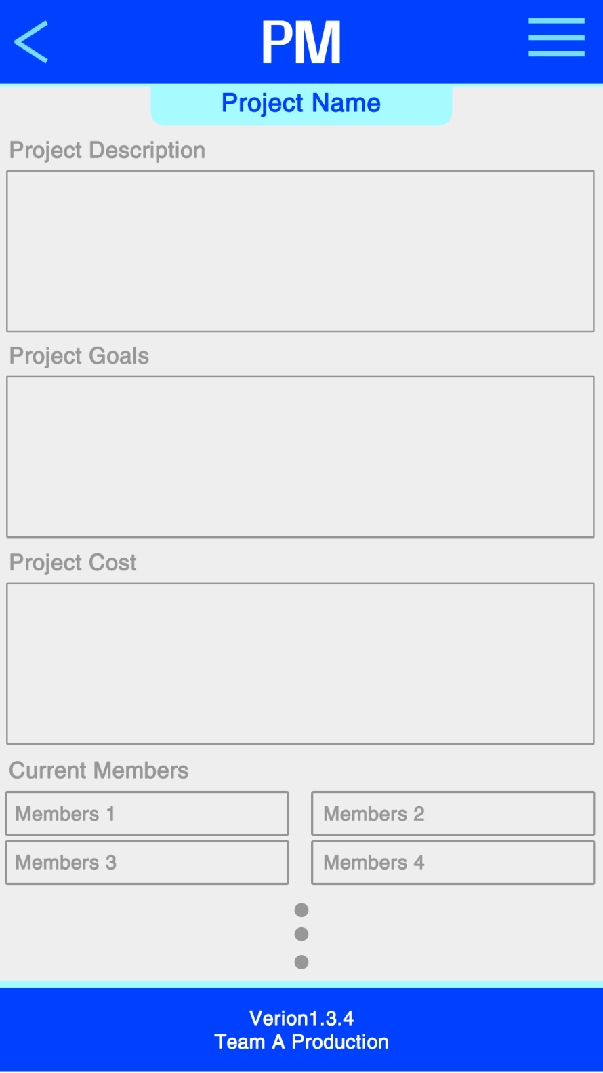

**3.9 Profile Screen**

The profile screens where members can see the people currently working in the project. This screen display a member’s picture, name, username, position, his or her starting date, phone and email address.

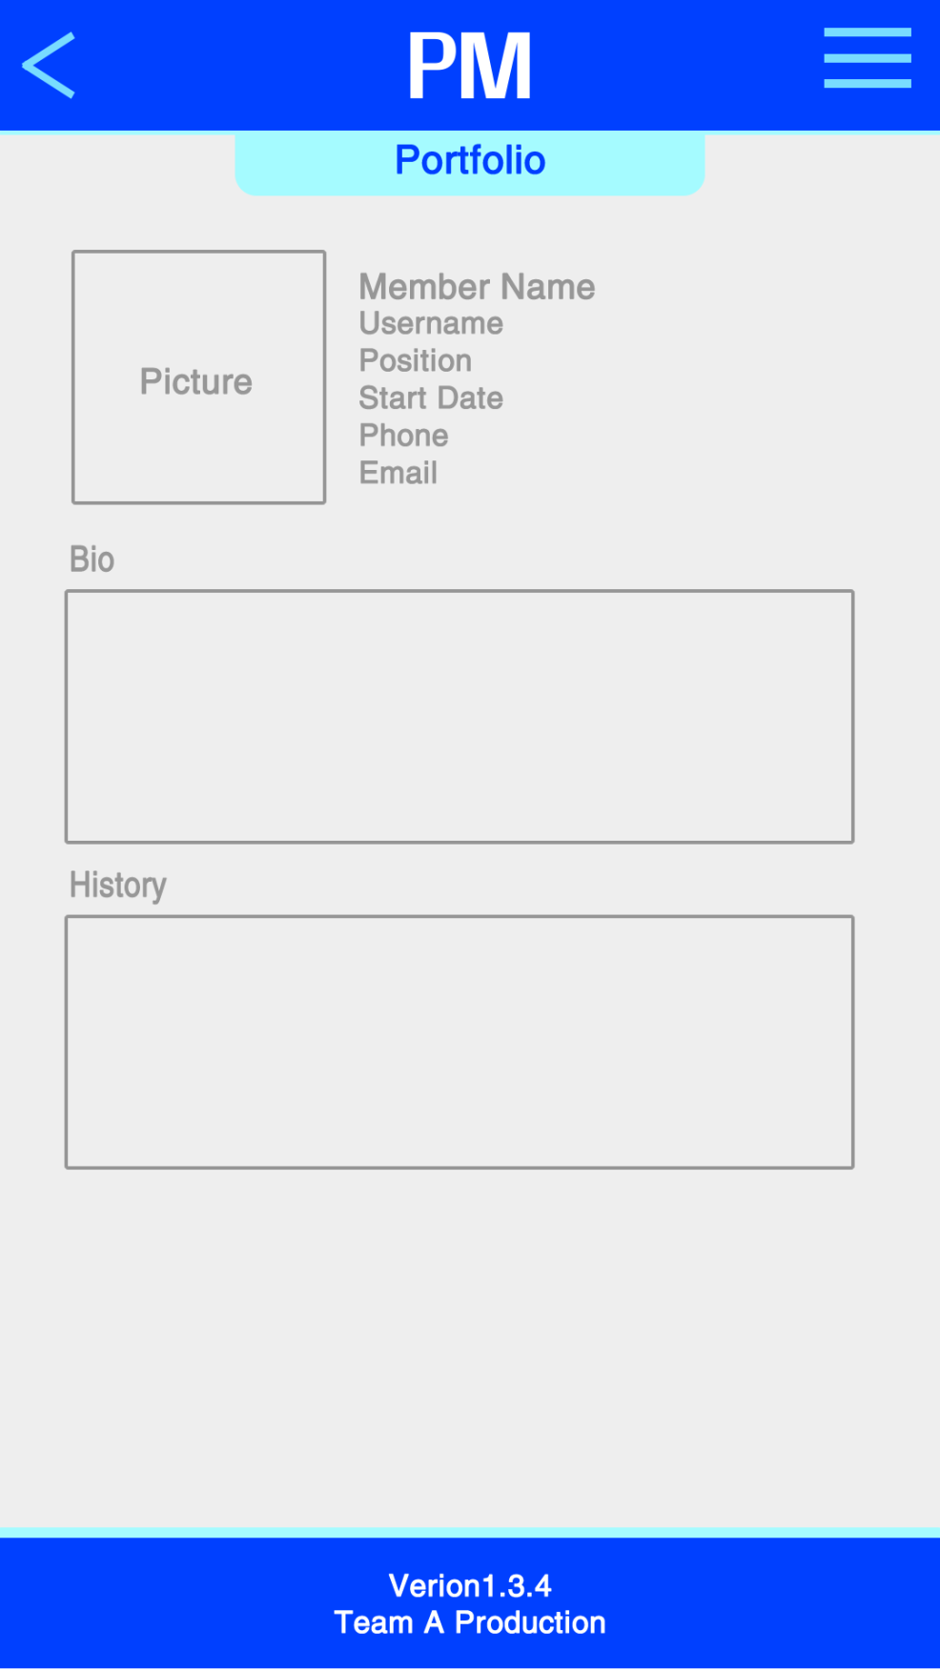

**3.10 Member’s View Screen**

The Member’s view screen is the most important screen to a member because from this screen, a member could check the assigned task progress, the task, access to messeging serivece, calendar, the project description and other services.

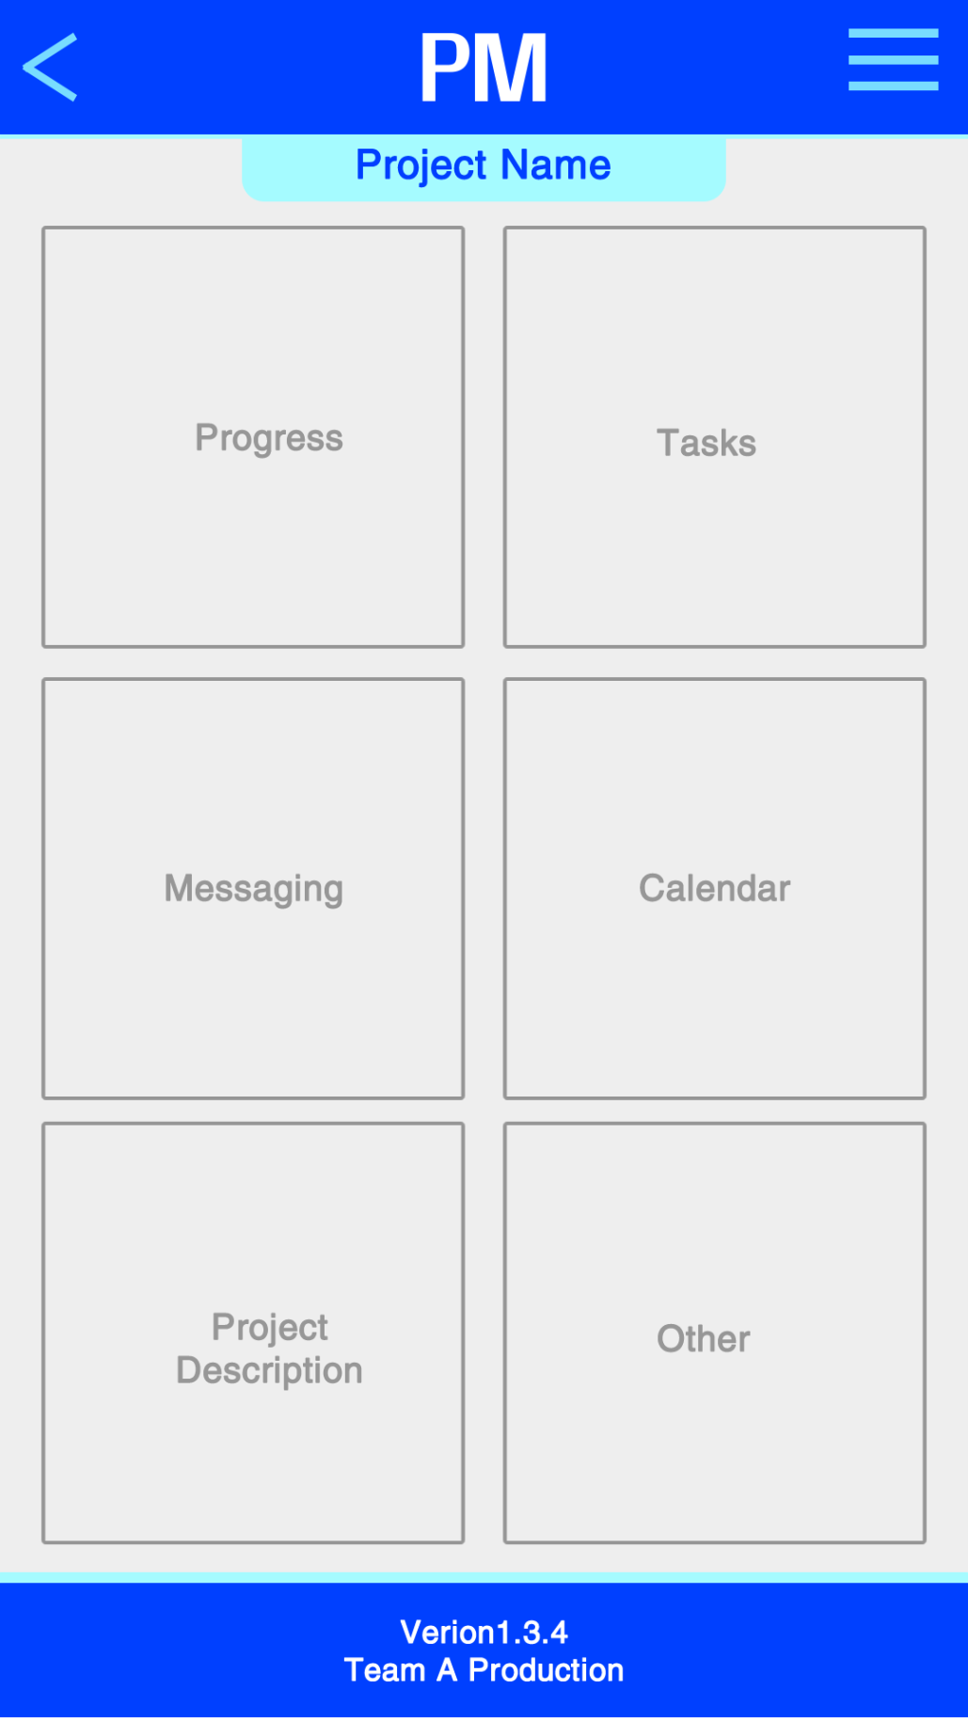

**3.11 Leader’s View Screen**

The leader view screen is very similar to the member’s view screen but with more added features and privilege. The leader from this screen, can see the project and members’ tasks progress. He or she can use as well the messaging interface provided by the app, the calendar with all assigned tasks due date, view a description of the project and each members who are currently working in the project.

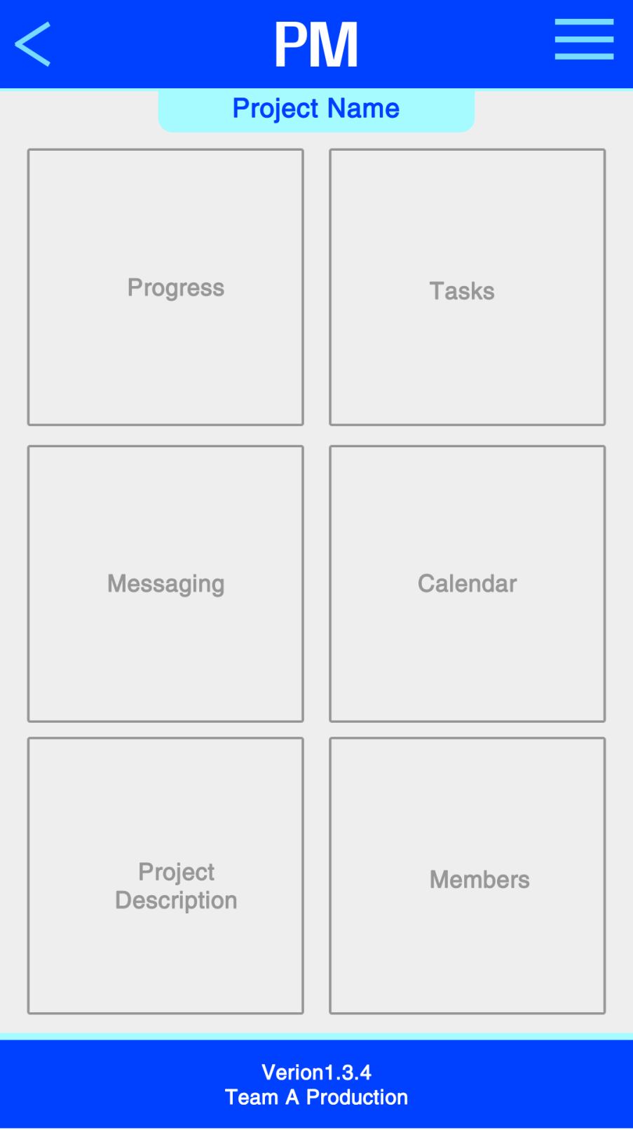

**3.12 Progress Screen**

The progress screen serves as a visual representation of the project’s progress and individual task progress. This screen is very useful because it gives the leader and members an idea if the its deadline of completion.

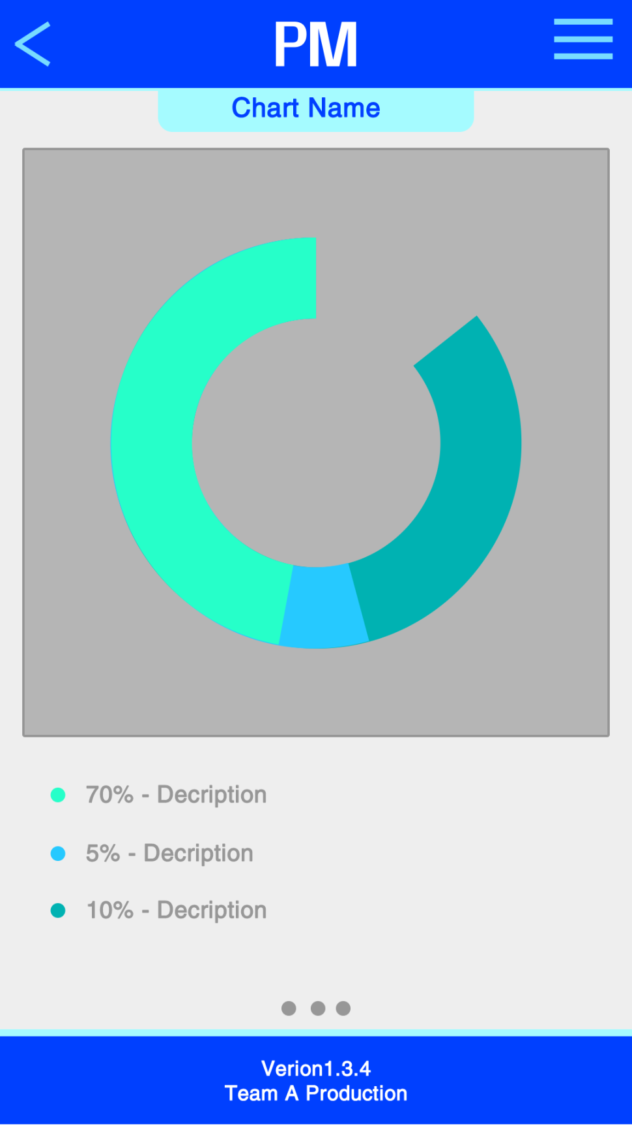

**3.13 Calendar Screen**

The calendar screen is very useful when used with the progress screen because the user can deduce if they are going to meet the deadline of the project or individual task. The calendar show the members the due date of each task and to the leader the due date of the project.

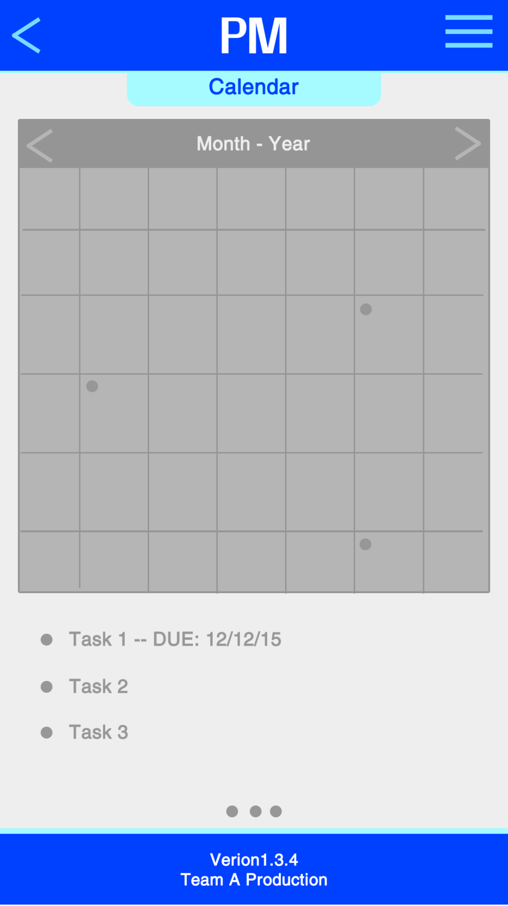

**3.14 Task List Screen**

The task list screen list or the tasks of the current project. This screen is only available to the leader of the project.

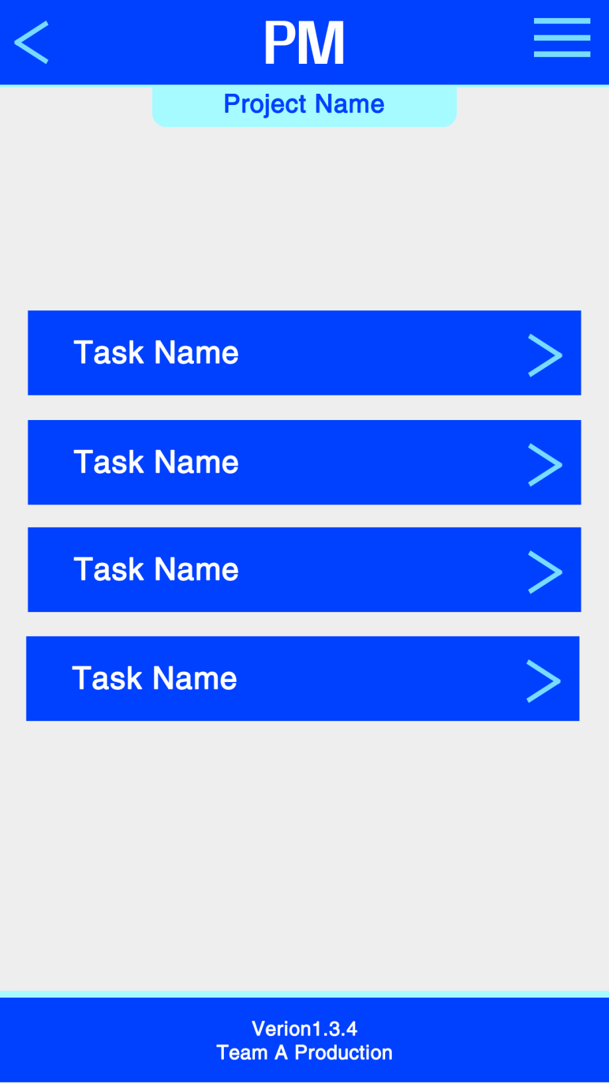

**3.15 Message Screen**

This screen is one of the most fun to use because of its synchronous communication interface. It is like text messaging the only different is that both users have to be members of the project to establish a communication session.

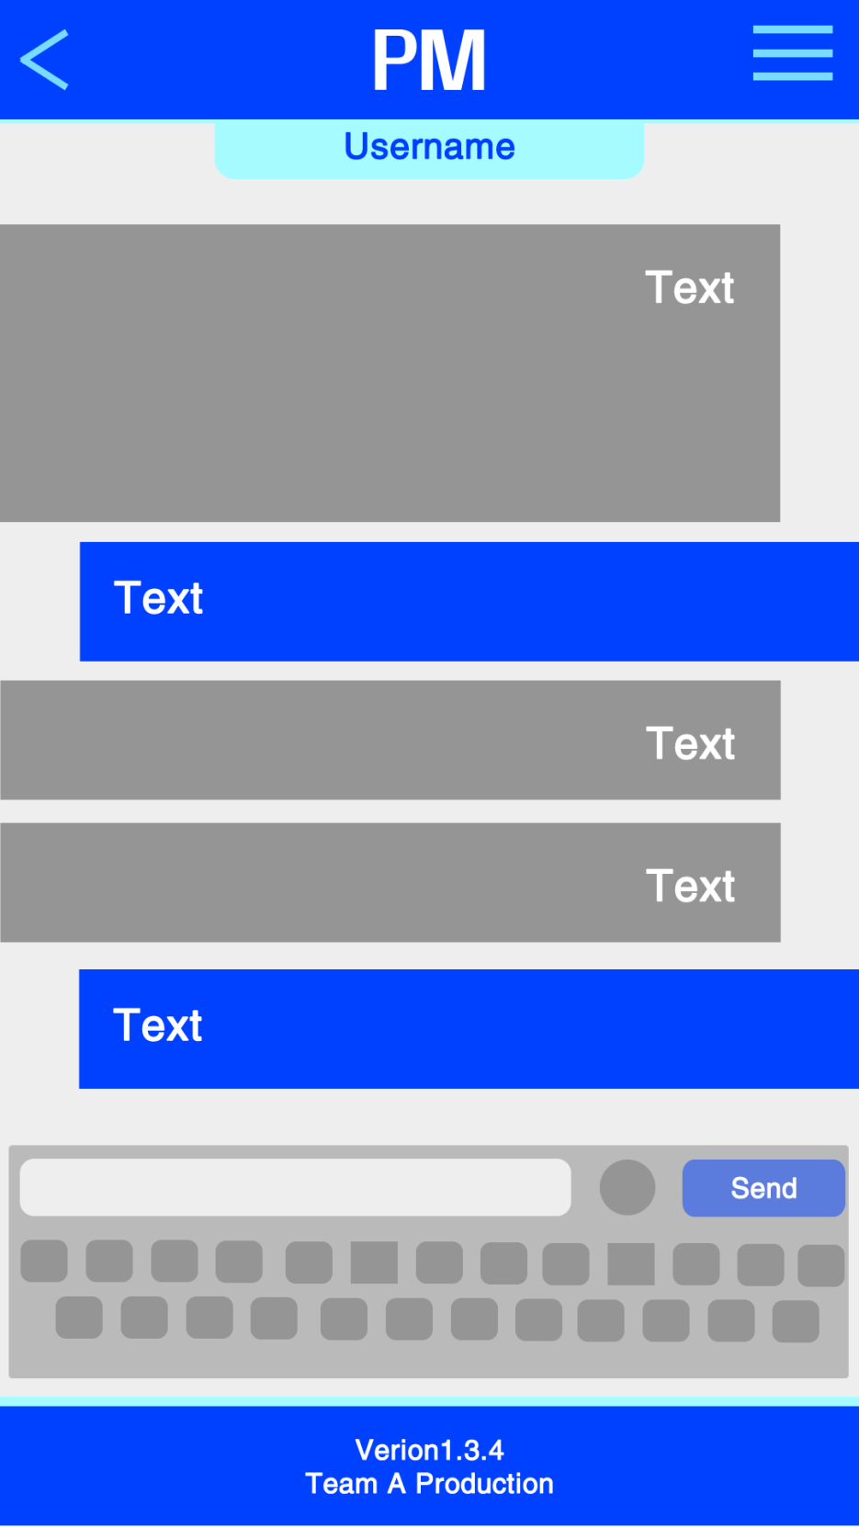

**3.16 Member List Screen**

This screen is only visible to the leader. The leader in this screen could see all members of the project.

